1. Wale is having trouble getting enough exercise, so he decides to start tracking his trips to the gym each week. After ten weeks of tracking, Wale has produced the distribution below.
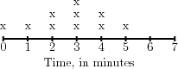
(a) Describe the overall shape of the distribution.

(b) What are the mean and median of the distribution?

(c) Suppose that next week, Wale doesn’t go to the gym at all. How would that affect the mean and median of the distribution?

2. Lil Wayne is a video game designer. He recently gathered some information on the number of hours that people play his game each week.
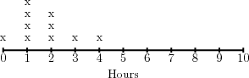
(a) What is the mean of the distribution? The median?

(b) What is the mean absolute deviation? The interquartile range?

(c) How would you describe the shape of the data?

3. Willow Smith is an employee at Facebook, and she has been asked to collect data on the amount of time that users spend on the site each week. Willow Smith decides to display that data in the chart below.
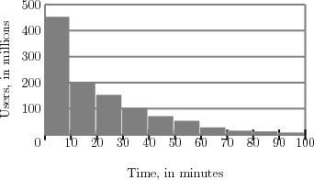
Describe the data by its shape and spread (range).

4. Tim Tebow believes that youth basketball players aren’t spending enough time practicing their free throws. So, in the summer Tim Tebow holds a free throw challenge. In the first round, each competitor shoots 10 free throws, yielding the results below.
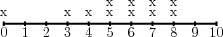
(a) How many competitors participated?

(b) What was the mean number of free throws sunk? The median?

(c) What is the interquartile range? The mean absolute deviation?

