Name__________________________

Directions: Describe the shape of the data distribution using words from the word bank below.
Word Bank:
Bimodal Unimodal Normal Distribution Gap
Cluster Outlier Skewed Right Skewed Left

Dot Plots
1)
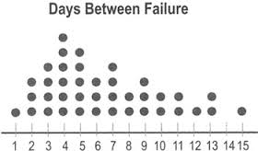

2)
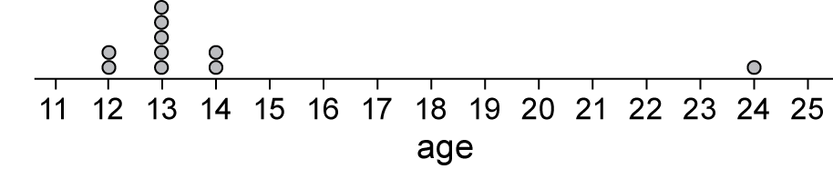

3)
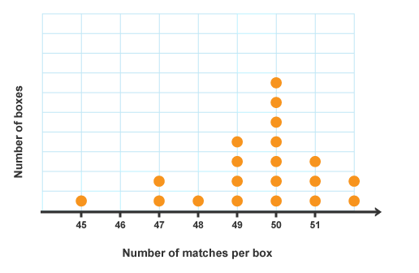

1)

2)

3)

Histograms
4)
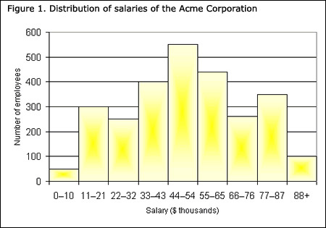
5)
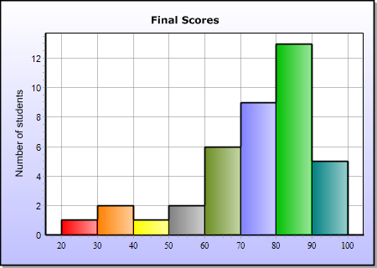
6)
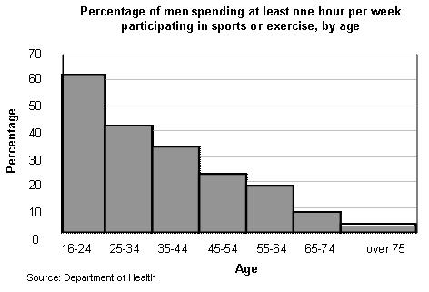

4)

5)

6)

Box Plots
7)
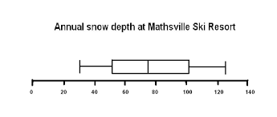

8)
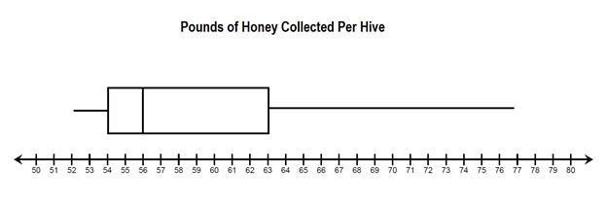

9)
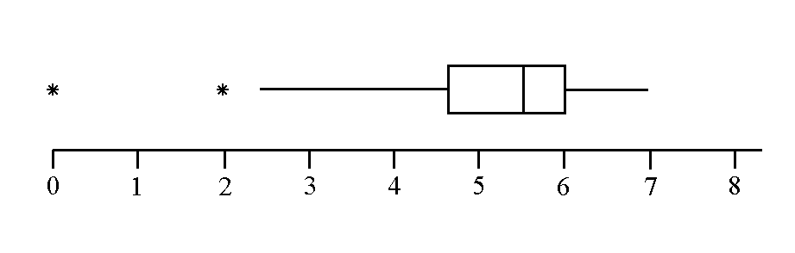

10) Name the 3 ways that data can be described by its center. Name the 3 ways that data can be describes by its spread.

7)

8)

9)

10)
Center Spread
1. 1.
2. 2.
3. 3.

