Missing Value Class Work

1. Caylum will take a total of 4 science tests this trimester. He wants to have a mean score of 90 at the end of the trimester. How many total points does Caylum need in order to have a mean score of 90?

2. Daniela is training for 6 weeks to prepare for a road race. She wants to have a mean running distance of 15 miles for her 6 weeks of running. How many miles does Daniela need to run in total to reach her goal?

3. Kathy will take a total of 5 mathematics tests. She has taken 4 mathematics tests so far. The scores on her first 4 tests are shown below.
1) 85
2) 89
3) 92
4) 84
5) ?
What score must Kathy get on her 5th test in order to have a mean score of 90 on all 5 of her mathematics tests?

4. Jasper is training for 6 weeks to prepare for a road race. He has run for 5 weeks so far. The distances he ran during his first 5 weeks are shown in the table below.

Jasper’s Running Distance

Week | Distance (in miles)
1 | 15
2 | 19
3 | 23
4 | 28
5 | 31
6 | ?

What distance must Jasper run in his 6th week in order to have a mean running distance of 25 miles for his 6 weeks of running? Show or explain how you got your answer.

5. Zeke’s goal is to read a mean of 40 minutes per day for one week. For the first 6 days of the week, he read 36, 40, 38, 43, 45, and 30 minutes. What is the number of minutes Zeke must read on the 7th day of the week to reach his goal exactly?

6. Below is a chart that shows Nethanya’s social studies quiz scores for the past unit.

Name | Quiz 1 | Quiz 2 | Quiz 3 | Quiz 4 | Quiz 5 | Desired Mean
Nethanya | 93 | 83 | 98 | 100 | ? | 90

Without doing any calculations, predict what score Nethanya must get on her next quiz to meet her goal of a 90 average. Explain your reasoning.

Missing Value Notes
Vocabulary Review

Mean: the balance point or average of a data set

How to find the mean:

1) Add up all of the values in the data set

2) Divide the sum by how many values there are in the data set

Missing Value: the number that you need in a data set in order to reach a specific mean

Example Problem:

Edward is training for 4 weeks to prepare for a road race. He has run for 3 weeks so far. The distances he ran during his first 3 weeks are shown in the table below.

Week | Distance (in miles)
1 | 38
2 | 47  Missing Value
3 | 42
4 | ?

What distance must Edward run in his 4th week in order to have a mean running distance of 40 miles for his 4 weeks of running?

Mean

Steps for finding a missing value:

- Place the given data points in each box on the left side of the scale (include a box for the unknown value)

?
42
47
38

- Put the desired mean in each box on the right side of the scale

?
42
47
38
40
40
40
40
40
40
40
+40
160
- Add up the right side

- Add up the left side
38
47
+42
127

- Find the difference between the two sides.

Miles Needed 160
-Miles So Far 127
Run #4 33

Missing Value Class Work – Version 2

1. Caylum will take a total of 4 science tests this trimester. He wants to have a mean score of 90 at the end of the trimester. How many total points does Caylum need in order to have a mean score of 90?

_____________ groups of _____________ = _____________

2. Daniela is training for 6 weeks to prepare for a road race. She wants to have a mean running distance of 15 miles for her 6 weeks of running. How many miles does Daniela need to run in total to reach her goal?

_____________ groups of _____________ = _____________

3. Kathy will take a total of 5 mathematics tests. She has taken 4 mathematics tests so far. The scores on her first 4 tests are shown below.
1) 85
2) 89
3) 92
4) 84
5) ?
What score must Kathy get on her 5th test in order to have a mean score of 90 on all 5 of her mathematics tests?

Actual Scores Desired Mean
Hint:

Points Needed
-Points So Far
Test #5

4. Jasper is training for 6 weeks to prepare for a road race. He has run for 5 weeks so far. The distances he ran during his first 5 weeks are shown in the table below.

Jasper’s Running Distance
Week | Distance (in miles)
1 | 15
2 | 19
3 | 23
4 | 28
5 | 31
6 | ?
Hint:

Miles Needed
-Miles So Far
Run #6

What distance must Jasper run in his 6th week in order to have a mean running distance of 25 miles for his 6 weeks of running? Show or explain how you got your answer.

5. Zeke’s goal is to read a mean of 40 minutes per day for one week. For the first 6 days of the week, he read 36, 40, 38, 43, 45, and 30 minutes. What is the number of minutes Zeke must read on the 7th day of the week to reach his goal exactly?

6. Below is a chart that shows Nethanya’s social studies quiz scores for the past unit.

Name | Quiz 1 | Quiz 2 | Quiz 3 | Quiz 4 | Quiz 5 | Desired Mean
Nethanya | 93 | 83 | 98 | 100 | ? | 90

Without doing any calculations, predict what score Nethanya must get on her next quiz to meet her goal of a 90 average. Explain your reasoning.
Hint: Look at Nethanya’s scores so far. Are they higher or lower than her goal?
Think about the stacks of cubes. Would you have to add a stack higher than 90 or lower than 90 so that each stack has 90?

Missing Value Class Work - KEY

1. Caylum will take a total of 4 science tests this trimester. He wants to have a mean score of 90 at the end of the trimester. How many total points does Caylum need in order to have a mean score of 90?
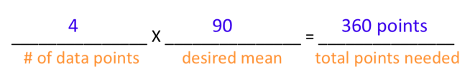
2. Daniela is training for 6 weeks to prepare for a road race. She wants to have a mean running distance of 15 miles for her 6 weeks of running. How many miles does Daniela need to run in total to reach her goal?
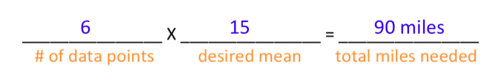
3. Kathy will take a total of 5 mathematics tests. She has taken 4 mathematics tests so far. The scores on her first 4 tests are shown below.
1) 85
2) 89
3) 92
4) 84
5) ?
What score must Kathy get on her 5th test in order to have a mean score of 90 on all 5 of her mathematics tests?

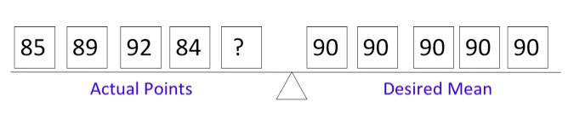

Points Needed 450
- Points So Far 350
Test #5 100
Answer:
100 points

4. Jasper is training for 6 weeks to prepare for a road race. He has run for 5 weeks so far. The distances he ran during his first 5 weeks are shown in the table below.

Week | Distance (in miles)
1 | 15
2 | 19
3 | 23
4 | 28
5 | 31
6 | ?

What distance must Jasper run in his 6th week in order to have a mean running distance of 25 miles for his 6 weeks of running? Show or explain how you got your answer.

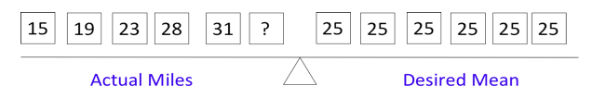
Answer:
34 miles
Miles Needed 150
- Miles So Far 116
Run #6 34

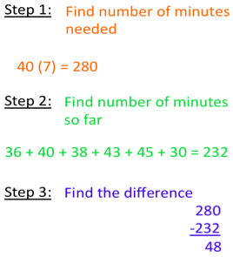
5. Zeke’s goal is to read a mean of 40 minutes per day for one week. For the first 6 days of the week, he read 36, 40, 38, 43, 45, and 30 minutes. What is the number of minutes Zeke must read on the 7th day of the week to reach his goal exactly?

6. Below is a chart that shows Nethanya’s social studies quiz scores for the past unit.

Name | Quiz 1 | Quiz 2 | Quiz 3 | Quiz 4 | Quiz 5 | Desired Mean
Nethanya | 93 | 83 | 98 | 100 | ? | 90

Without doing any calculations, predict what score Nethanya must get on her next quiz to meet her goal of a 90 average. Explain your reasoning.

Out of Nethanya’s four quizzes, three quizzes are slightly above her desired mean of 90 points and one quiz is slightly below the desired mean. Therefore Nethanya is currently above her desired mean. If she were at her desired mean, she would need a 90 to maintain her grade. Since she is above her desired mean, I would estimate that she would need about an 85 to meet her goal.

