1. Adrian Peterson is taking his entourage to an Indian restaurant for dinner. Adrian Peterson’s entourage is so large that he has to order the food in advance. Adrian Peterson asks his friends to record their spiciness preferences from 0-10, as seen below:
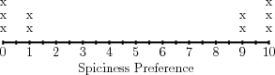
In order to decide which spiciness level to order, Adrian Peterson decides to find the center of the distribution.
(a) What are the mean and median of the distribution?

(b) What do the mean and median not tell us about the distribution?

(c) How many people will be happy if Adrian Peterson orders food at the mean or median spiciness level?

2. Macklemore is a software developer working on a new photo-sharing app. Before he starts building the app, Macklemore interviews 10 potential customers to find out how many photos they take per week, yielding the data below.
0, 0, 1, 4, 10, 10, 12, 13, 15, 25
(a) What is the mean number of photos taken?
(b) The median?
(c) Explain what the mean and median tell you about the data set.
(d) What don’t they tell you?
3. Beyonce is leading a discussion on time management. At the beginning of the discussion, she asks everyone to write down how many emails they receive each day. Then, she collects all of the responses and arranges them from least to greatest.
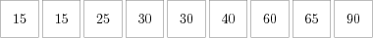
(a) Beyonce wants to summarize the data using measures of center and spread. Help her to calculate the
i. mean
ii. mean absolute deviation
iii. median
iv. interquartile range.

