Name:__________________________

**Dot Plots**

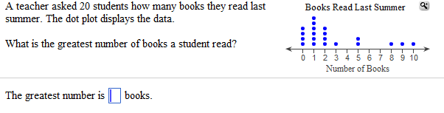

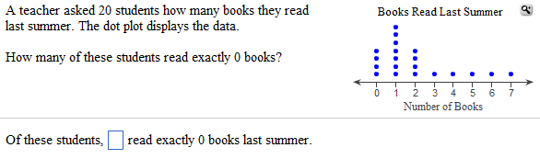

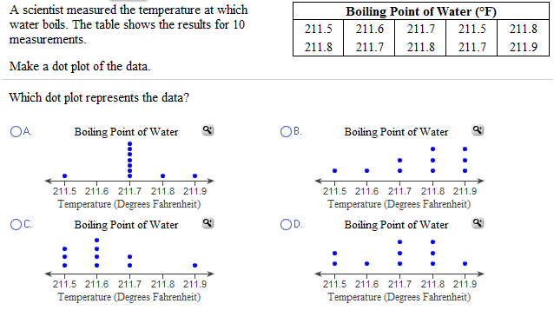

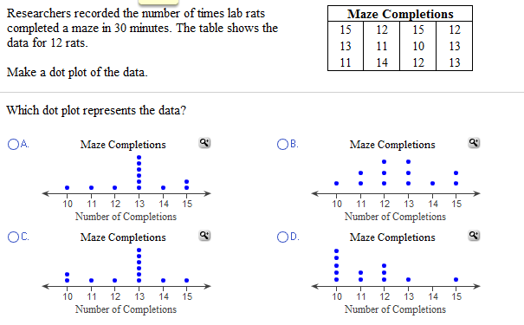

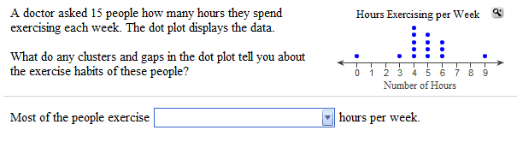

**Histograms**

