1. Beyonce is a math teacher. On Beyonce’s last math test, her students earned the following scores:
82, 96, 91, 100, 94, 78, 100, 90, 95, 88, 92, 98, 100, 82, 93, 80, 94, 90, 76, 90, 84, 100, 82, 96
(a) Use the data to complete the frequency table below:
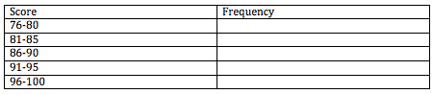
(b) Make a histogram of the data.
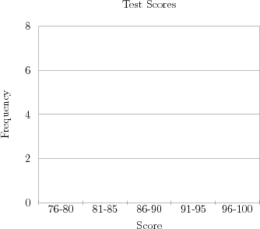

2. The ages, in years, of the 28 members of a gym class are listed in the box below.
Construct a box plot of the data in the list. Use the number line to construct your plot.
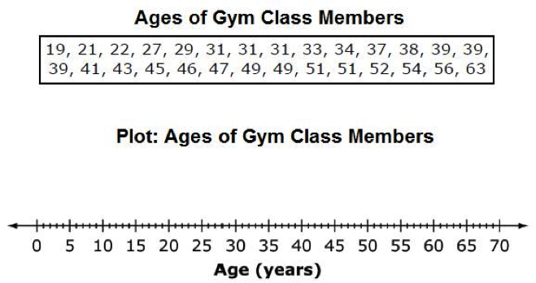

3. In June 2010, opponents of the NY Yankees scored the following number of runs.
4, 4, 9, 0, 2, 4, 1, 2, 11, 8, 2, 2, 5, 3, 2, 4, 0.
(a) Make a dot plot for the data.
(b) Describe the distribution of this data set.

