1. The bar chart represents the outcome of a penalty shoot-out competition. Each person in the competition was allowed six shots at the goal. The graph shows, for example, that four people only scored one goal with their six shots.
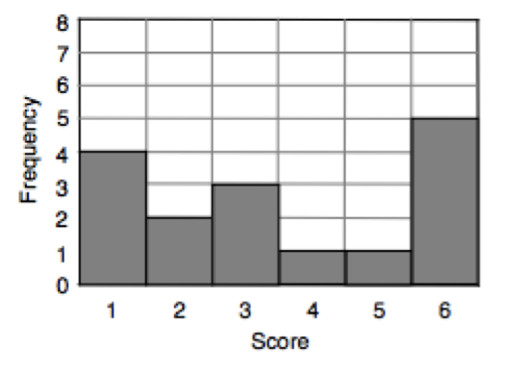
(a) How many people were involved in the shoot-out?

(b) Find the values for the Mean and Median, and explain how you calculated each answer.

2. You have been given the wait times for some popular attractions.
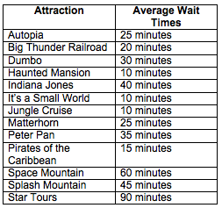
(a) Which ride has the shortest wait time?
(b) Which ride has the longest wait time?
(c) What is the difference between the wait times?
(d) If you were to ride the attractions from shortest wait time to longest wait time, which attraction would you ride in the middle?
(e) What is the most common wait time?
(f) If you went on all 13 rides one time, how much total time did you spend in line?
(g) What was the average wait time?
(h) Your friend told you he waited in line for the Matterhorn for 40 minutes. Who is lying, Disneyland or your friend? Explain.

