1. Usain Bolt keeps two pens of chickens in his back yard (for the eggs).
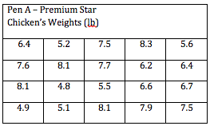

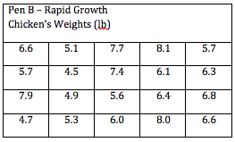
(a) How many chickens are in each pen?

(b) What units are used to measure the chickens’ weights?

(c) What is the mean weight of the chickens in each pen? The median?
2. The dot plot shows the number of runs scored by a baseball team in games played during the month of April.
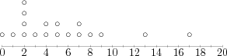

(a) What does each dot represent?

(b) How many games did the team play in April?

(c) How does the range of the data help you decided the interval for the frequency table?

(d) Make a frequency table for the data.

