1. The RBIs (Runs Batted In) for 15 players from the 2010 Seattle Mariners and Baltimore Orioles are shown. Use the data to answer the following questions.
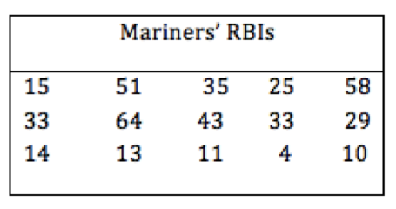 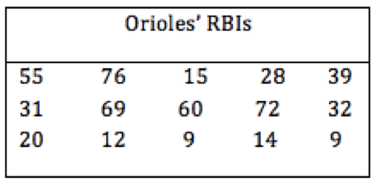
(a) Find the median of the Mariners’ RBIs.
(b) Find the lower quartile of the Mariners’ RBIs.
(c) Find the upper quartile of the Mariners’ RBIs.
(d) Make a box plot of the Mariners’ data.
(e) Find the IQR of the Mariners’ data.
(f) Find the median of the Orioles’ RBIs.
(g) Find the lower quartile of the Orioles’ RBIs.
(h) Find the upper quartile of the Orioles’ RBIs.
(i) Make a box plot of the Orioles’ data.
(j) Find the IQR of the Orioles’ data.
(k) Using the information found, make a statement that compares the RBIs for the two teams.

