6.SP.1 Recognize a statistical question as one that anticipates variability in the data related to the question and accounts for it in the answers.

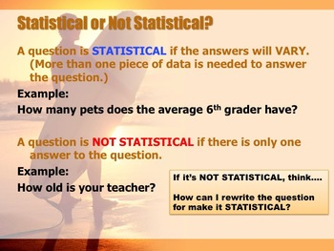
6.SP.2 Understand that a set of data collected to answer a statistical question has a distribution, which can be described by its center, spread, and overall shape.

Measures of Center
- Mean
- Median
- Mode
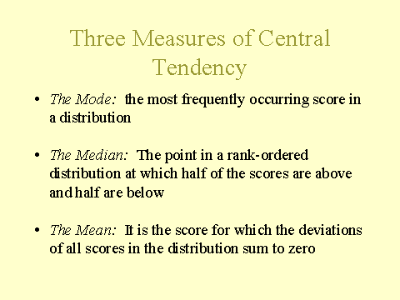
Student Notes:

Measures of Spread (Variability)
- Range
- Interquartile Range
- Mean Absolute Deviation
Range – The difference between the largest and smallest number
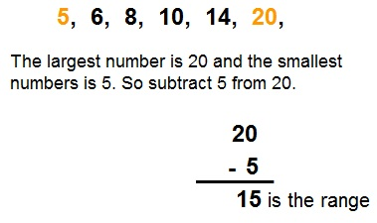

Interquartile Range - The range between the quartiles
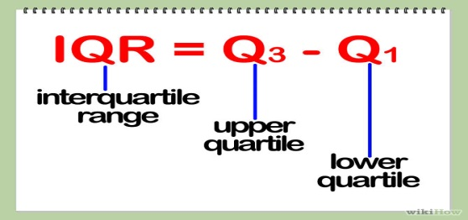

Mean Absolute Deviation: The average distance of all of the datafrom the mean
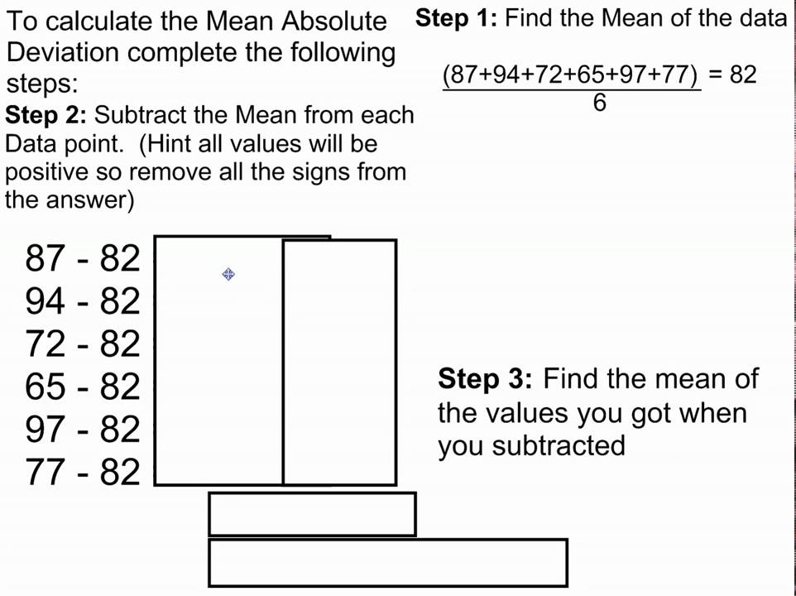
Student Notes:

Shape
- Skewed right
- Skewed left
- Outlier
- Gap
- Cluster Normal distribution
- Unimodal
- Bimodal
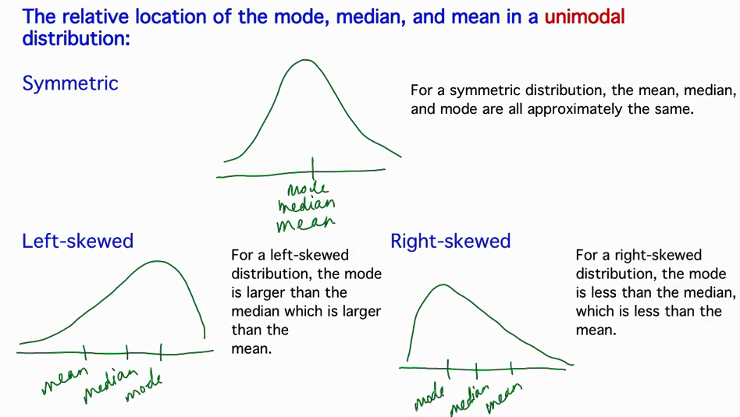

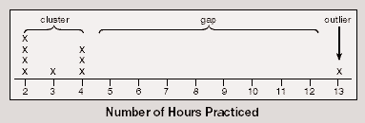

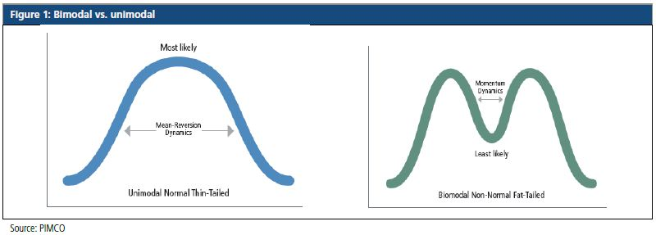

Student Notes:

6.SP.3 Recognize that a measure of center for a numerical data set summarizes all of its values with a single number, while a measure of variation describes how its values vary with a single number.

Example 1: Consider the data shown in the dot plot of the six trait scores for organization for a group of students.
- How many students are represented in the data set?
- What are the mean and median of the data set? What do these values mean? How do they compare?
- What is the range of the data? What does this value mean?

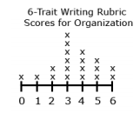
6.SP.4 Display numerical data in plots on a number line, including dot plots, histograms, and box plots.
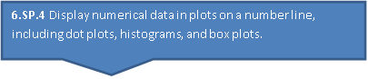
Example 1: Nineteen students completed a writing sample that was scored on organization. The scores for organization were 0, 1, 2, 2, 3, 3, 3, 3, 3, 3, 4, 4, 4, 4, 5, 5, 5, 6, 6. Create a data display. What are some observations that can be made from the data display?
Student Notes:

Example 2: Grade 6 students were collecting data for a math class project. They decided they would survey the other two grade 6 classes to determine how many DVDs each student owns. A total of 48 students were surveyed. The data are shown in the table below in no specific order. Create a data display. What are some observations that can be made from the data display?
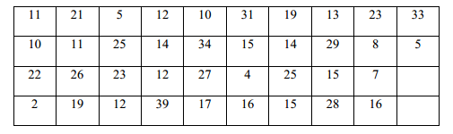
Solution: A histogram using 5 intervals (bins) 0-9, 10-19, …30-39) to organize the data is displayed below.
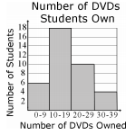
Most of the students have between 10 and 19 DVDs as indicated by the peak on the graph. The data is pulled to the right since only a few students own more than 30 DVDs.

Student Notes:

Example 3: Ms. Wheeler asked each student in her class to write their age in months on a sticky note. The 28 students in the class brought their sticky note to the front of the room and posted them in order on the white board. The data set is listed below in order from least to greatest. Create a data display. What are some observations that can be made from the data display?
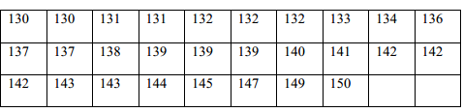
Solution: Five number summary
- Lower Quartile (Q1) – (132 + 133) ÷ 2 = 132.5 months
- Median (Q2) – 139 months
- Upper Quartile (Q3) – (142 + 143) ÷ 2 = 142.5 months
- Upper Extreme – 150 months
- Lower Extreme – 130 months
This box plot shows that
- ¼ of the students in the class are from 130 to 132.5 months old
- ¼ of the students in the class are from 142.5 months to 150 months old
- ½ of the class are from 132.5 to 142.5 months old. The median class age is 139 months.
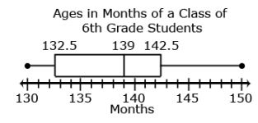

Student Notes:

6.SP.5 Summarize numerical data sets in relation to their context, such as by:
a. Reporting the number of observations.
b. Describing the nature of the attribute under investigation, including how it was measured and its units of measurement.
c. Giving quantitative measures of center (median and/or mean) and variability (interquartile range and/or mean absolute deviation), as well as describing any overall pattern and any striking deviations from the overall pattern with reference to the context in which the data were gathered.
d. Relating the choice of measures of center and variability to the shape of the data distribution and the context in which the data were gathered.

Example 1: Susan has four 20-point projects for math class. Susan’s scores on the first 3 projects are shown below:
Project 1: 18 Project 2: 15 Project 3: 16 Project 4: ____
What does she need to make on Project 4 so that the average for the four projects is 17? Explain your reasoning.

Example 2: What is the IQR of the data below:
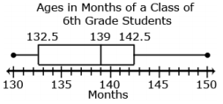

Example 3: The following data set represents the size of 9 families: 3, 2, 4, 2, 9, 8, 2, 11, 4. What is the MAD for this data set?
Student Notes:

